When doing anything on the site on the same page, do not open new window, use popup screen or use Angular Js to do it without loading the page again. We need to have smooth browsing by clicking here and result will show without reloading. Open new page for any thing is very old fashion and no body use now. Please, we should have the focus by hovering oven an object and see result on the other of the page. Additionally, we want to see counter update to show immediately without refreshing on Travfeed or wall pages

When doing any thing on the wall, we do not have to reload the whole page especially the header of the page, only the bottom of the page should load where we have the new data.

Notice we edit a post we should open a popup window rather than opening new page, the popup window to include the tool Box and then allow member to edit and then save the post.

When a member delete a post confirm with them with a popup screen to delete the post

When hovering over the member thumbnail photo and the enlarged screen showup, plz make it larger like 1.5 of current size. Also, show some information about the user like where they live, occupation, friend count etc… send message and view profile. More importantly it show up right a way not taking long time to popup

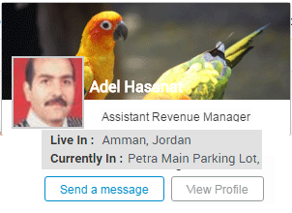
When any one do like or comment or share, the counter should increment count right a way not after we reload the page.

When new posting are added when member are viewing travfeed, should be show in the fly without refreshing the page.

When hovering over the header photo for the wall, it should allow the user to change it
Also, when hovering over the user photo, it should ask him to change it.

When click on Like, it show Like (1), but when refresh , the counter is gone.

When I Like a post, the counter get updated but my name will appear after I refresh the page under the post.

Make all Thumbnail photo for comment box and comment text and the Like the same size. Use comment and the like photo size

Align the all Thumbnail photo and all the text lines at the same left margin

Make the background color for the “view previous comments” gray

We need to create multiple account and test between them friend request, adding comment and see how the privacy work. Additionally we need to test multiple account and see how changing different field entries maintain it self.

How we are going to handle people logging from FB with regular signup user, when I change certain fields on my account, then log with FB , the items are over written by FB feed.
Logging with FB, the feed is importing the Thumbnail photo not the actual the photo.

2 | Mute friend functionalities, where to show mute friend button? When you right click on that friend,  we can have an item to mute all notifications from that friend. See FB
3 | User can report abuse for any unknown users ? Also right click on that user, an item should show to report that user  with a comment box to why he is abusing
4 | follow of the comment for each post ?? like FB
5 | Use Create Account icon when the member is done, Use Create Account icon when the member is done filling the page rather than  the Verify icon you are using now.
6 | Notice the progress timing that hold more information about the section. The one on the top that show each page that was  completed e.i signup, profile, interest, photo, done
7 | On User wall, if birthdate/mobile/email is empty then it display blank or not to display No display

Please look into the way the logo blue bar icon for travfeed look when enlarge the screen to 150 or 175%. As of now it shows as below. We need to move the search icon maybe in the 2nd row.

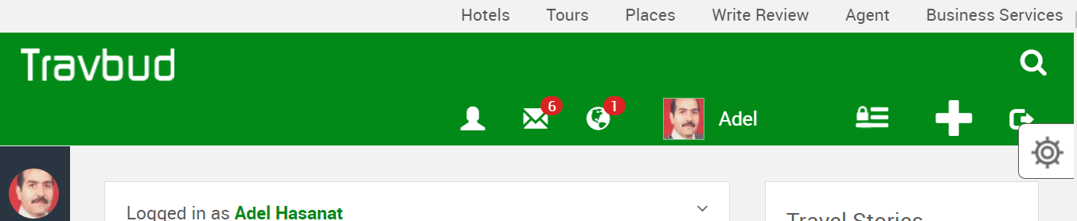

Top of Form

Under the Account setting
Modify the following

When entering unmatched password, the system save it without warning
.
City, allow for auto select which will include state and county which we can extract the state and country once Mobil to include country code pre set after they select the city, country needed from the that city entry. As shown below in the signup screen
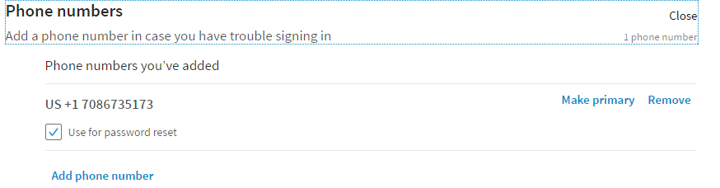

Birth date, modify the menu as discussed earlier or as shown below
Language, allow selection for most language not just three as of now.

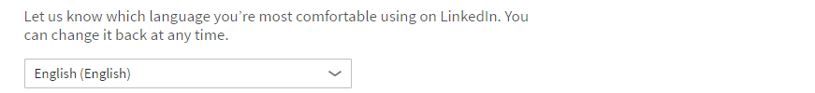
Edition, interest and occupation, allow for auto select. As shown below in the signup screen.

For the Photo section, please follow the given earlier instruction.
As shown below in the signup screen

Under the security section
For the security question use inside of the phone question, What city you born?

Under the Blocking lists
Who can see my posts? Change it to “People on this list cannot see my posts”
People on this list cannot interact with me Good
Block event invites from someone “People on this list can not send event invitation”

Privacy
Who can send friend request, should allow for Public and Friend of Friend and take out Friends because they are already are friends.
Dashboard View Permission
Can search engine look my dashbroad up? Show the current setting or use the animation
Add this item Who should be to see my friend list

Also add Anonymously browse other people's profiles (for VIP only)

Notifications

Play a sound when new notification is received Off
Play a sound when a message is received Off

Please use the same all over the site for security either “Private” or “Only Me” because sometime we are using either “Private” and some time we are using “Only Me”

Please review the slide below at 200% the ( Mobil view) where the side menu need to show correctly to hide the text that partially showing and allow me to expand it on the Mobil. Also notice the friend request screen output shortcut.

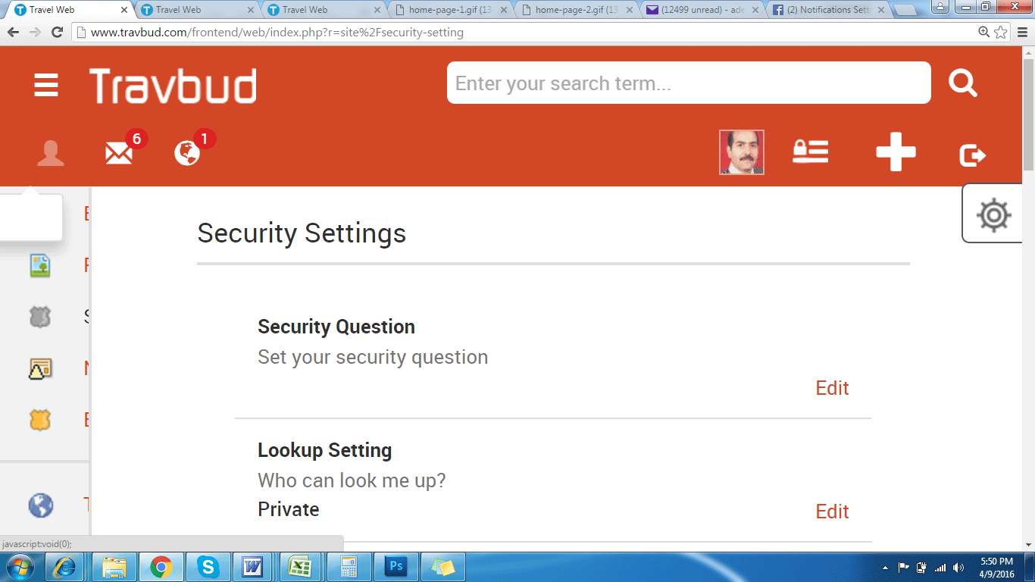

Please review the side below and fix the permission setting output at 150% and 200% where we can just move to the next line similar to the slide above. Also notice the friend request screen output shortcut. Additionally make these permission font to be gray not black as is now for all screen sizes
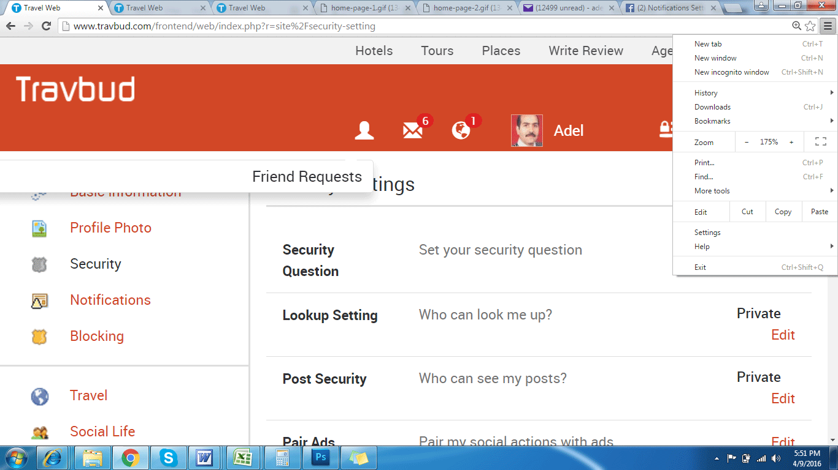

Password Reset

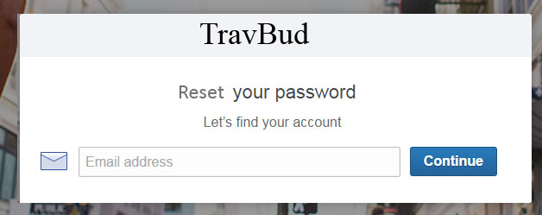

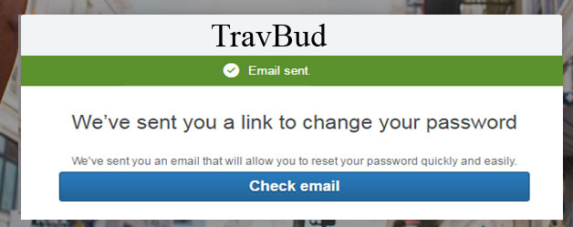

When the user click on the link, they should get a password screen to add there new password and confirm it.

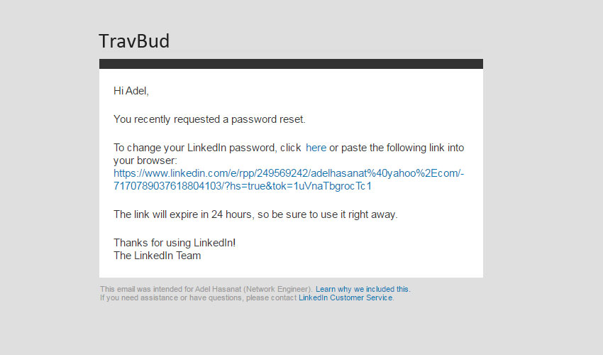

Use the progress time as shown below under the blue bar on each page, check twoo.com or youtube.com they have something similar. Use orange or yellow color for the line when runong the progress timer. Also make sure the logo bar is around 40-45 pixels high

When loading an image in the posting Tool Box please use the following method as shown in the couple images while the Post icon is dim out until the image is completely loaded then the Post icon is available for the user to click on it and post the image. Notice I took out the side borders and the tool box expand as needed while loading the image and text, it looks good. Please allow for more than one image addition in any post

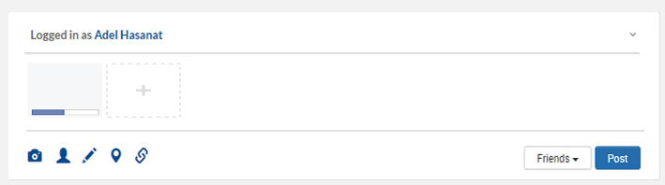

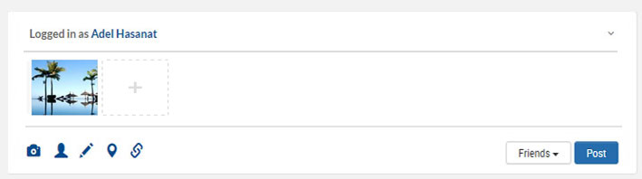

As of Now when editing any post and save it, it disappears from Travfeed posting page.

Please add new item “Message” next to the Like Comment Share to make it look different fromFB
Please take the Share Now(Friend) and Share menu out and implant it is Popup screen.

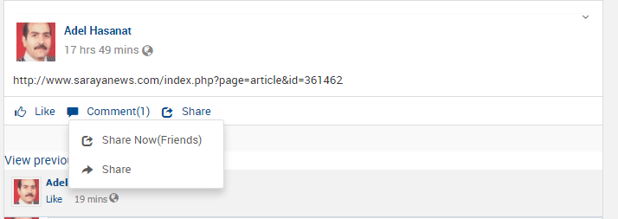

If no Friend Requests are in the system, please state No friend Request in the box as shown below
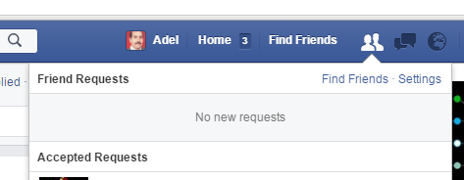

Notifications Alert Box, should show item as listed below. The Notifications should on line or two only in gray background separated with gray thin line

- Notifications when someone like or share or comments on member post or photo...
- All notifications about activity that involves my groups.
- Notifications when people who aren't your friends start following you and share or comment on your public posts.
- Notify me when get a friend request or confirm friendship.
- When I get eCard or postcard or eGift.
- When member invite me for a meeting.
- Notify me when a friend ask a question or responded to a question.
- When my credits is near tipping point or tipped up.

Hide Post menu item is no longer showing under the post menu, please add it back and check it to work after you hide a post and then refresh the page to see if it is still hidden.

Show the Comment count or the Share count the same you show the LIKE count plz

The loaded photos are shrinking when loaded a post before it used to expand based on the pixel count and photo size.

Allow the user to Pin any image in the travfeed posts when hovering over it to his gallery on the wall

Display three comments and then use the Previous comments and Next comments links to navigate between any post comments but we should only 5 comments per click.

Please allow user to Hide any comment on the post displayed.
Please allow comment owner to Edit or Delete his comment.
Please allow post owner to delete any comment on his post
Please allow the user to have one reply on any given comment.

_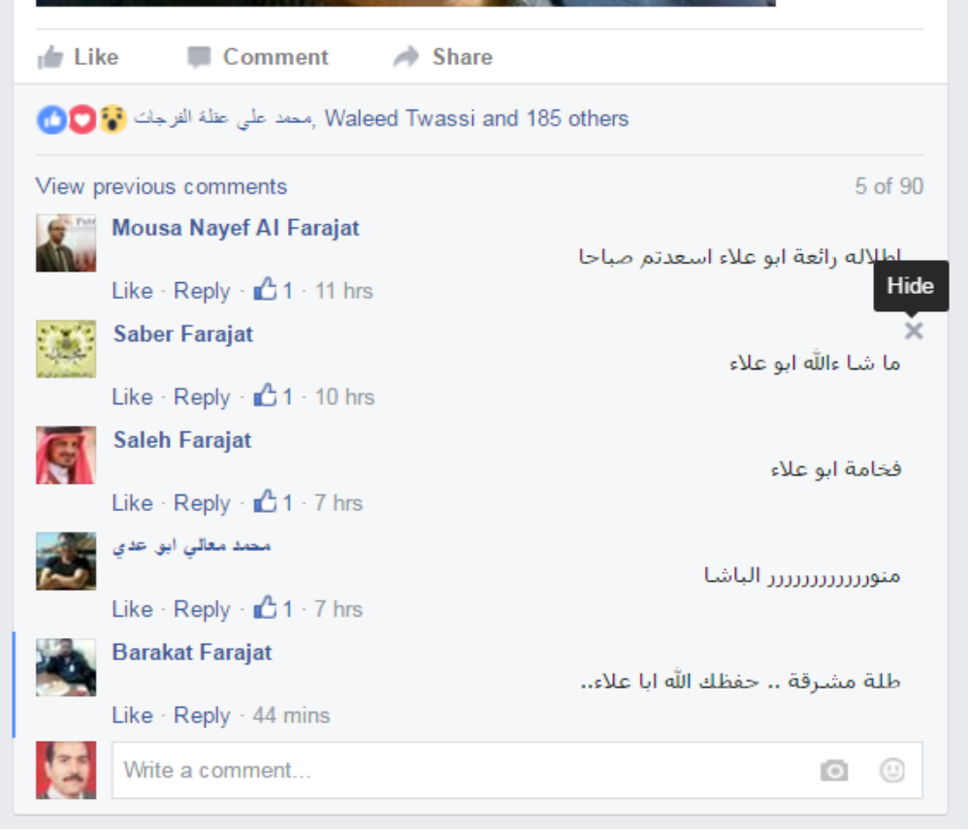

We do not need to show the bottom LIKE icon as who liked a post unless a member has the liked the post.

When a member click on Share then a popup screen (not a new window) with all the option for the user to select from as shown below from FB. No need for the Share menu on the travfeed page as done now, just go directly to the Share Popup screen and their show all the selections plz

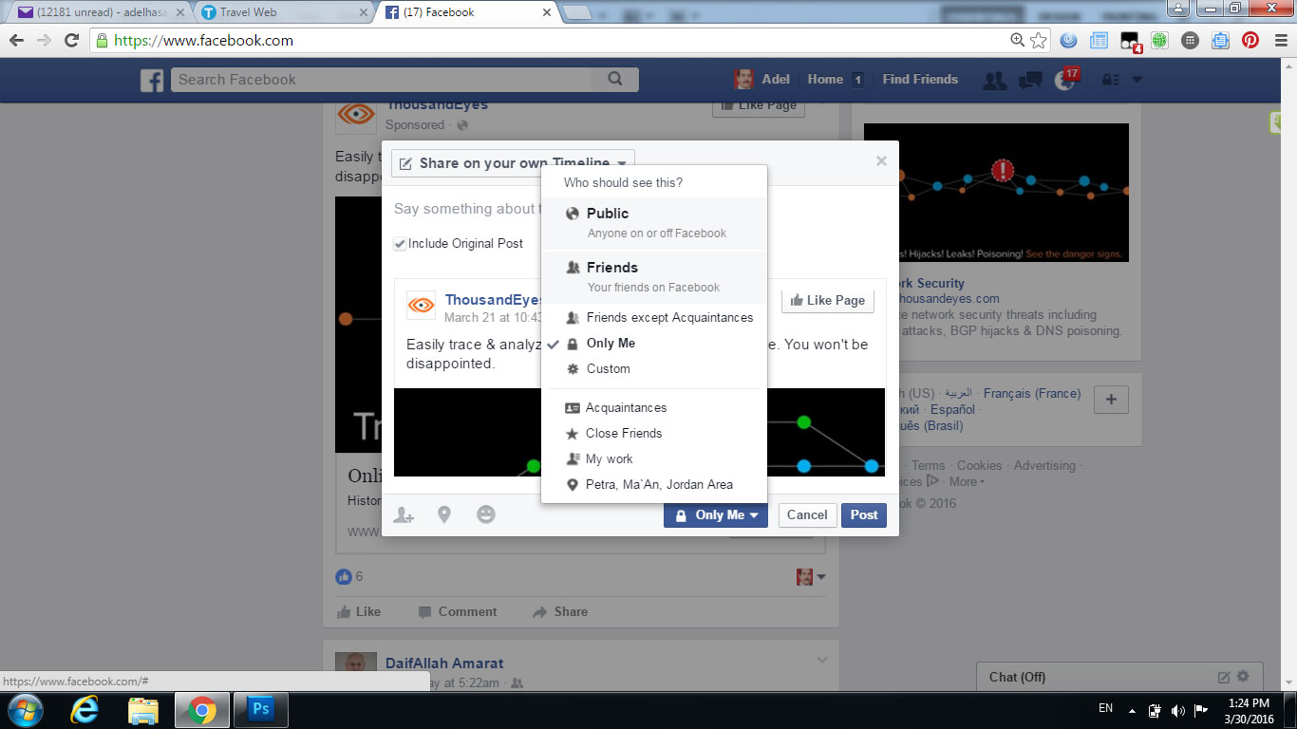

Please note the way birthdate calendar is handled, where the year and month day are showing in the same screen

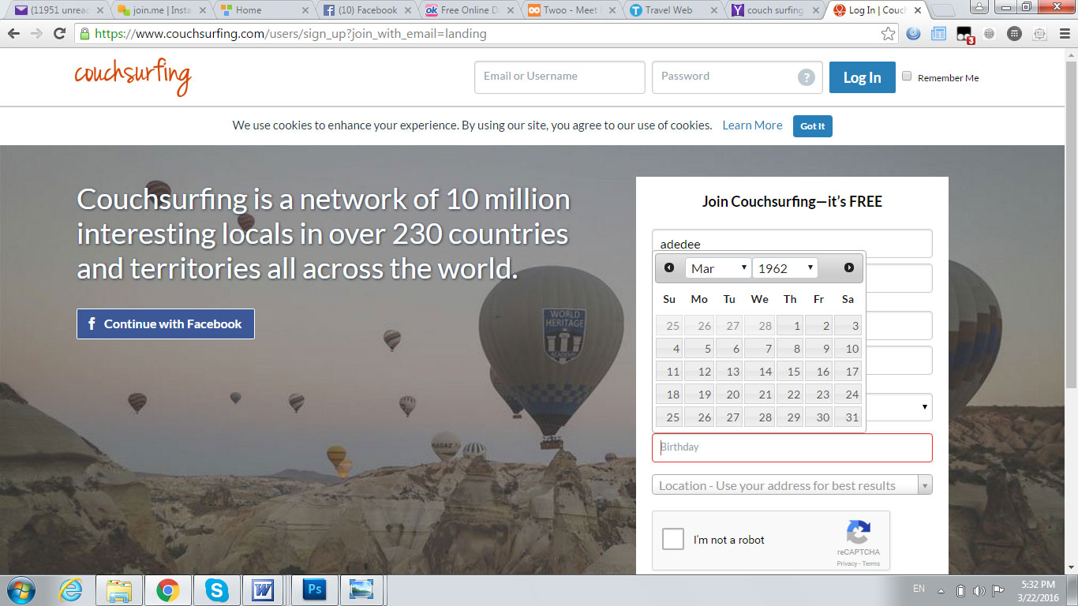

Please notice the numbers in pixels to show the column width and group of icon width and spacing between each group of icons on the top blue bar. Please notice that we are using thinner + sign font.

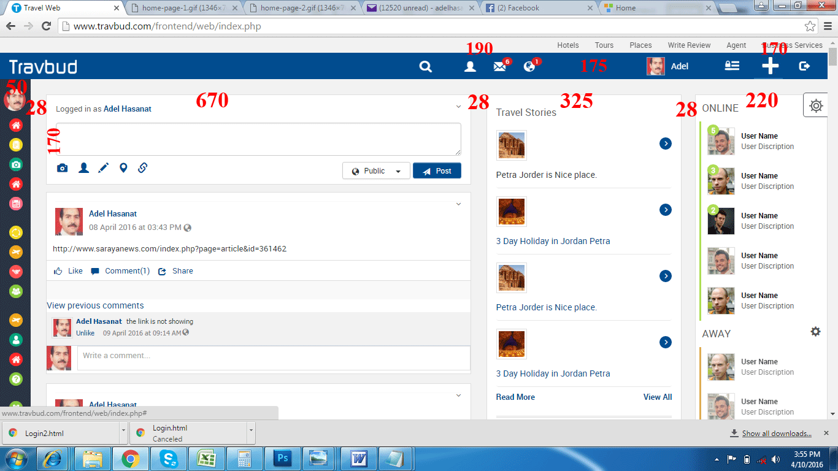

Set the page loading the style where the page load from the center to side for both the page and the travfeed and other pages for the whole page from.

Please test for, if the user enter the wrong Email or password, as of now the site do not inform the user what to do nor instruct the user of the problem. Check other site to what they and perform the same plz

Please use the Petra at night attached for the home page photo for now as it is 500k verse the one you are using is 1400k.

Please remove the Pipe sign between About, Pricey, Term, Contact Us on the home page footer

When entering unmatched password during the signup process, the system save it without warning

Please make the box width 300 pixels and height 40 pixels and height between each flied box 20 pixels
For the facebook connect box make it the same size as twoo.com
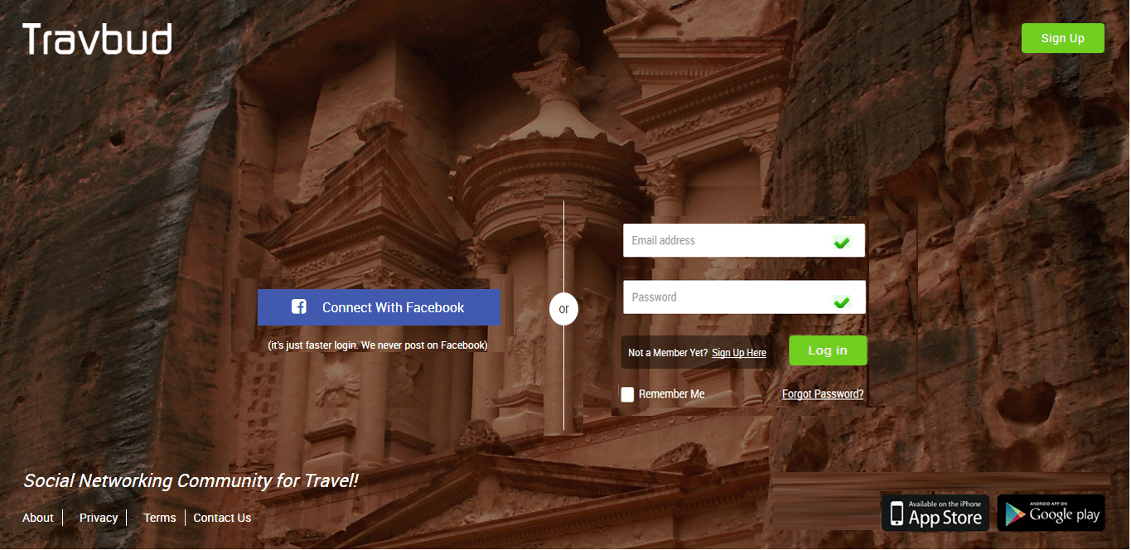

Please make the box width 300 pixels and height 40 pixels and height between each flied box 20 pixels
For the facebook connect box make it the same size as twoo.com
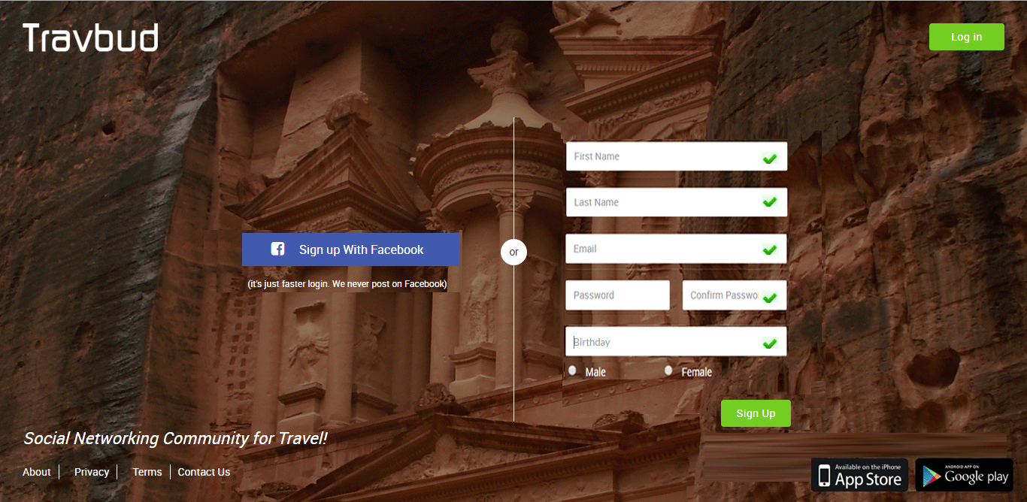

Please check the progress timer for the signup screens on the Mobil as of now it shows horizontally rather than being vertically.

Please Note to have the field Name is bold, we need to use darker color than the field text but we need to use the same color throughout the website to maintain consistey.
Notice the gray shade around the fields box.
Notice the progress timing that hold more information about the section. The one on the top that show each page that was compeleted e.i signup, profile, interest, photo, done
Please include the green check when the field is filled correctly and include a red X when is not filled correctly.
Allow member to set privacy for birthdate and Mobil num
For the Caption use adding two numbers and allow the member to put the value in the box
For example you may say “Add 3 and 2” and the member put “5” in the check box and that is good to verify that not a spam. Use signal digit only

Use Create Account icon when the member is done fill the page rather than the Verify icon you are using now.
Pre set the Mobil num with the country code
Now for the city we may use the approach I suggested earlier or we may use the approach in the profile page put we need to have it done automatically some what. While the country automatically populate by extracting the country info from the city selection.

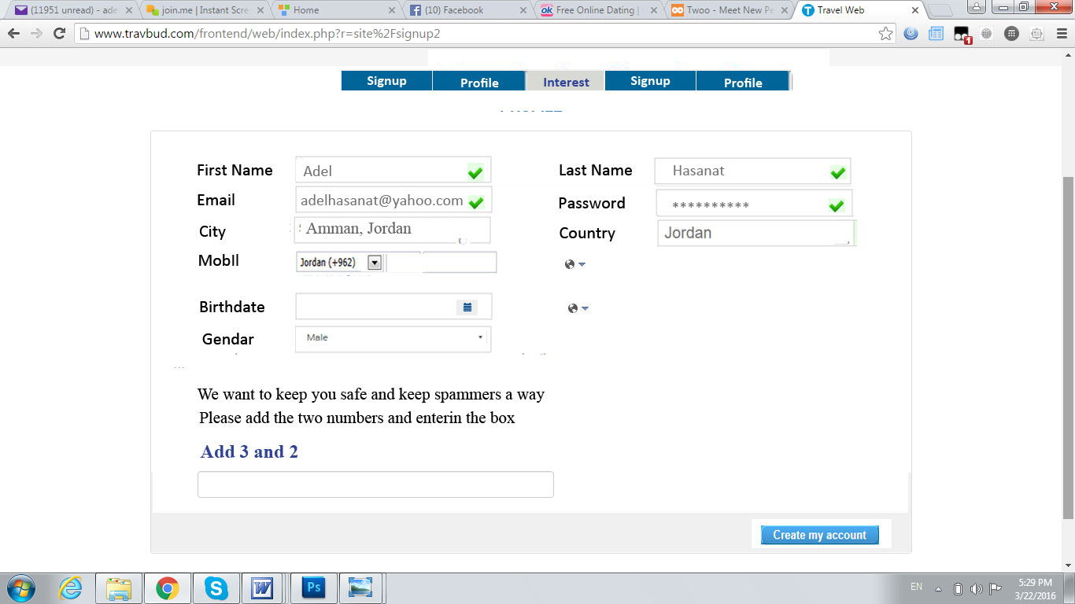

This the 2nd page in the registration process
We need to use selection as much as possible to allow for more easy way to fill the box
For example education, we may list the conmen degrees and high school listing for the user to choose from
For Occupations also we may list job allowing the member to choose from
For the languages also we can do a list
For interest we have to do check box kind of setup that allows the member to choose more that one item.
Please follow the design shown below for the hosting part

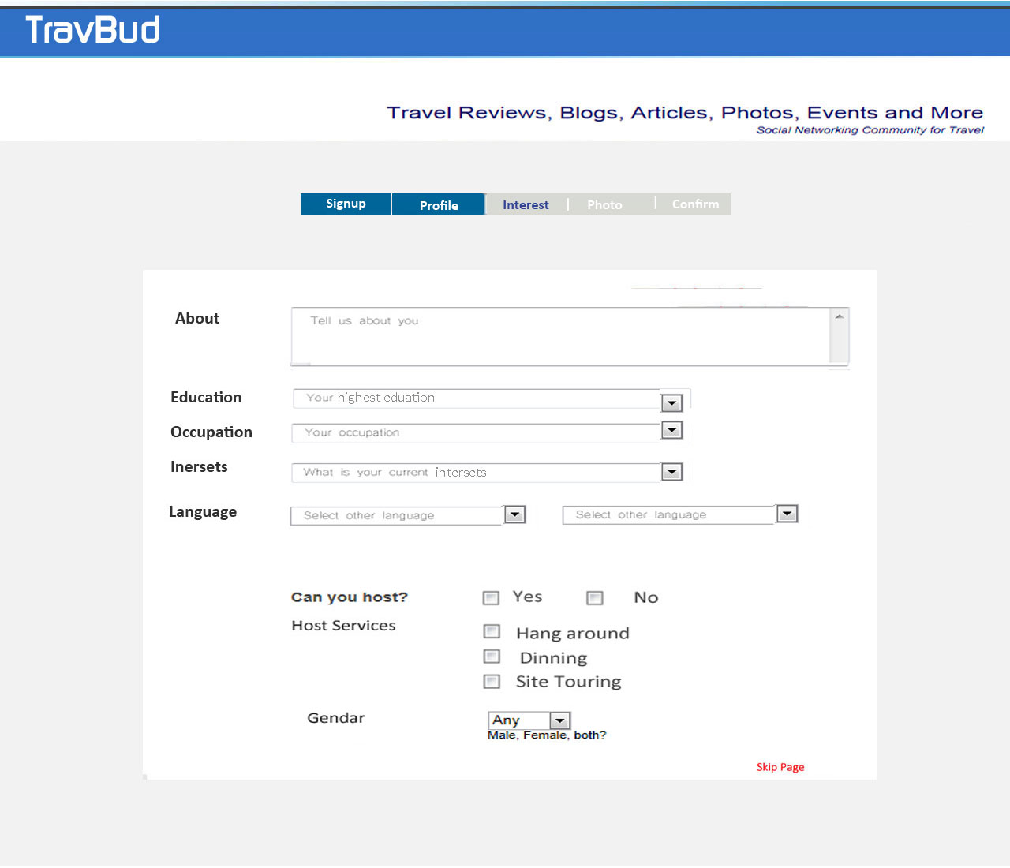

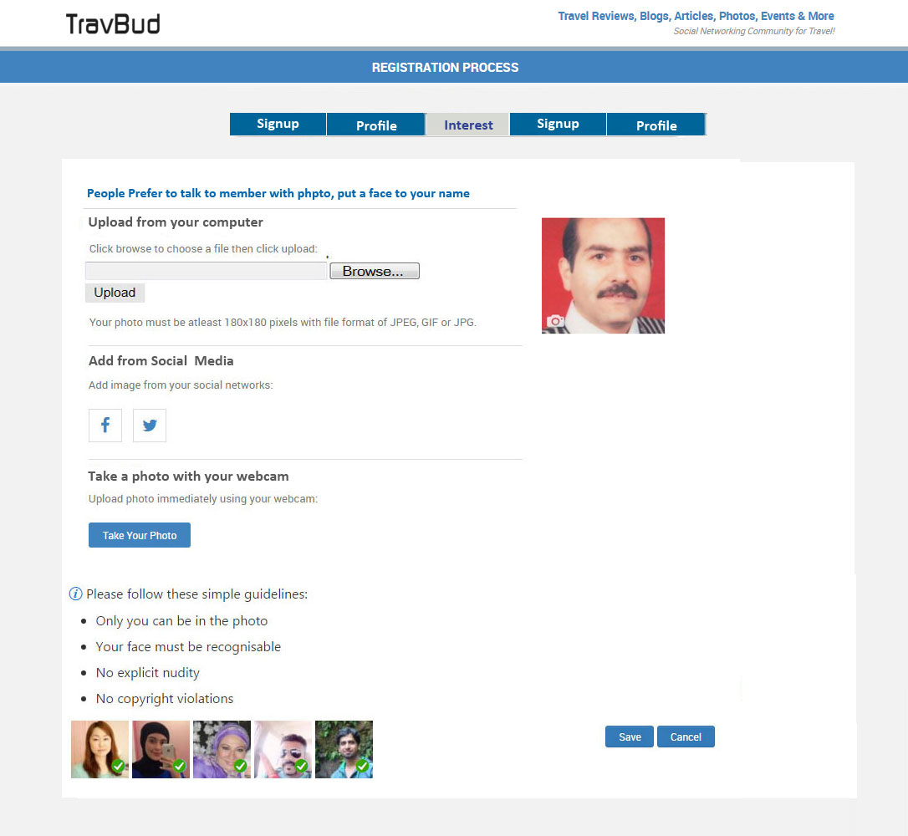

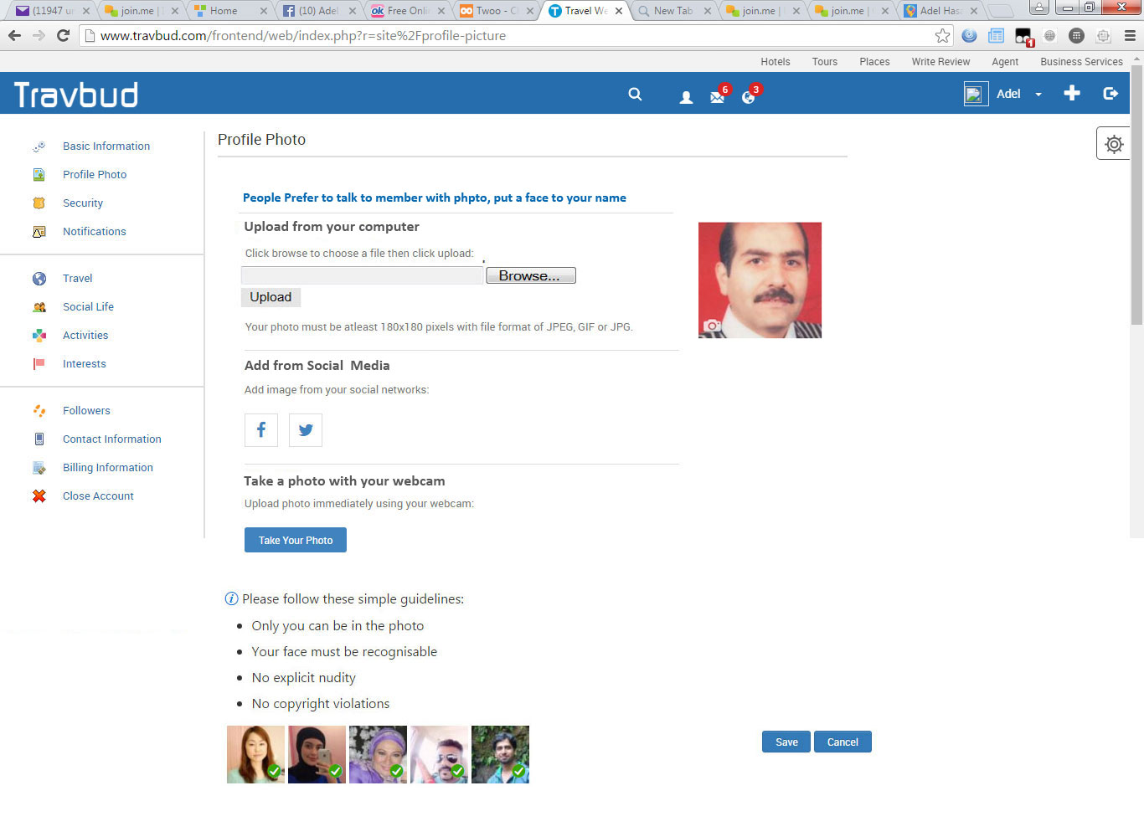

Please note the look of the photo, gallery, post, saved and wall Graphic Design look you may check Wayn.com
Please use the gray shadow level as shown in the image
Please use more bold and bigger font for the photo, friend …. As shown in the image
Please bay attention to divide the 3 columns by the gray shadow evenly Also the three columns will show the data column better in the Mobil
Please use simailer Map like in the image below.

Please use the following tabs look as shown below with lighter gray color.

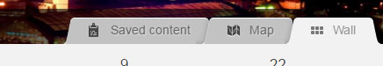

Check the about section to be similar to the following

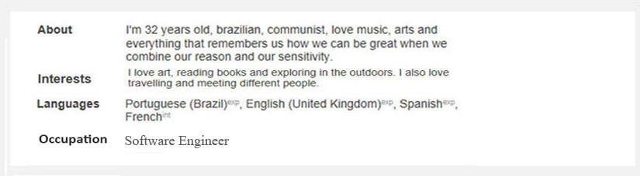

Please keep Photo, Blog, Review and Posts for Friend activities on the Wall
also take out the “Your” word fron the “Your Friend Activities” phrase on the Wall to make room on the Mobil

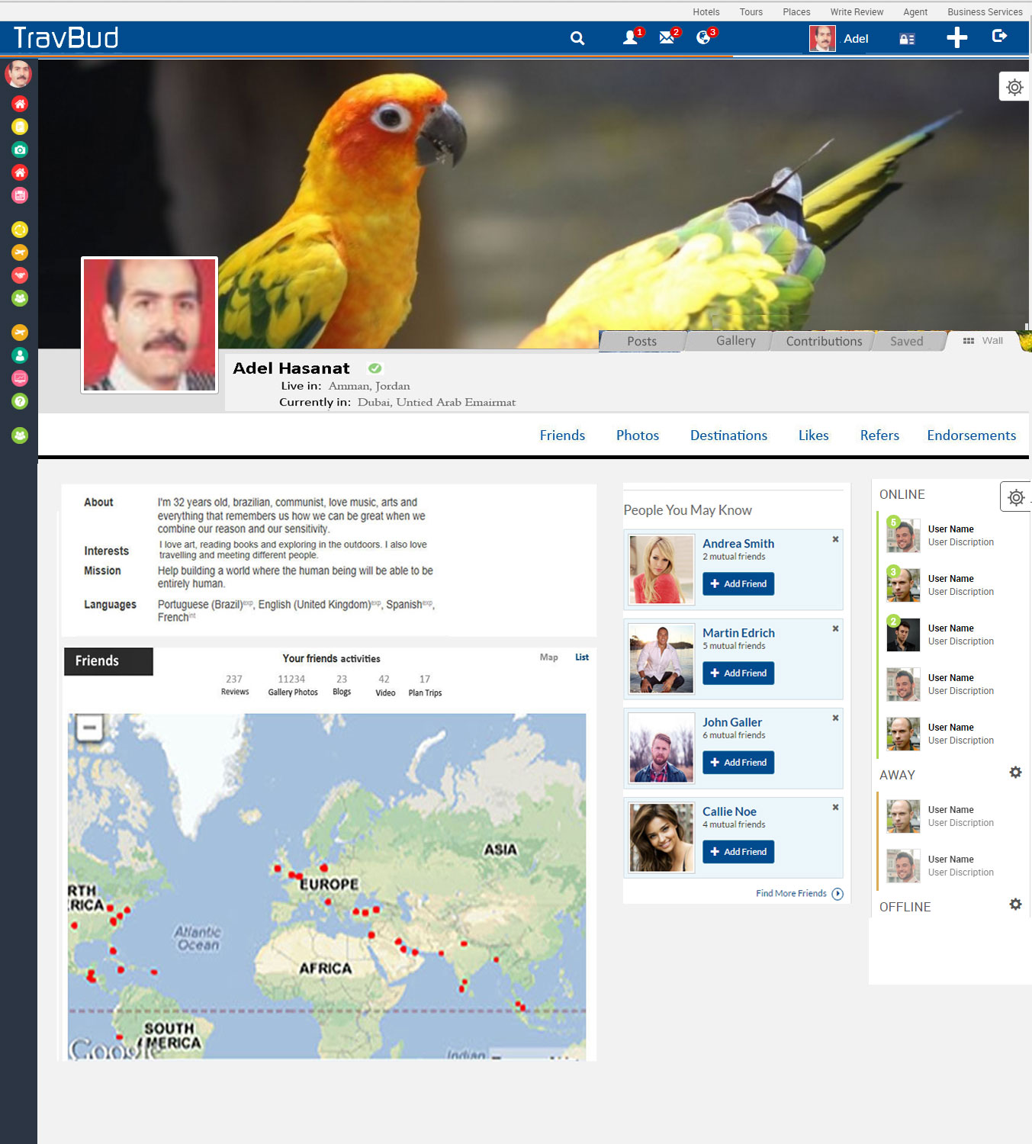

Use the above Map style for Friend, we need to use a different style for the destination as shown below.

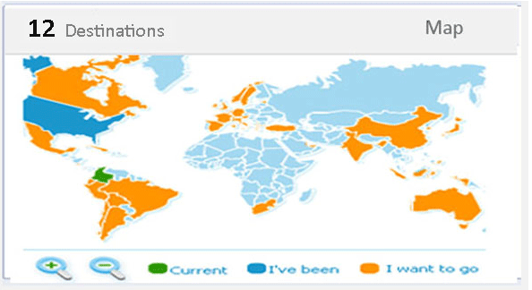
Please create new Navigation icon to reflect each menu item with the correct and our own icon to match the menu with suitable icon and also to prevent copy right. Keep the color of each icon as it is now but create the matching icon. There are a number of redundant icon and are not matching with the function of the item.

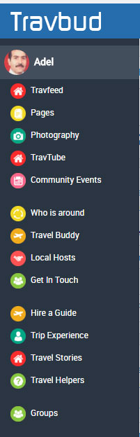

Please Notice that the Navigation on the left that some text at 150% and 175% is showing. In addition, we need a way to allow user to scroll down at this screen size. need an arrow to point down at the screen size that allow a user to click on it to allow user to scroll down

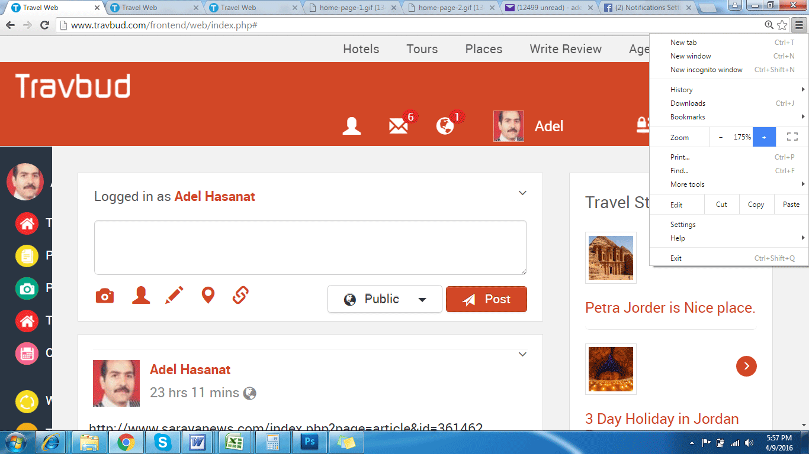

Please look at FB when loading a link, as when we add a link to Tool Box post, it load the link first with an image and some text while the post icon is dimmed. Once the link is loaded then we can post the image and the text as shown below.

